Expt 7.1 Spectral Estimation
Program:
clc; clear; close all fs=1000; t=(0:999)/fs; s=sin(2*pi*100*t)+0.5*sin(2*pi*200*t); n=0.3*randn(size(t)); x=s+n; figure, plot(x), grid on title('Signal with Noise') figure, periodogram(x,[],[],fs) title('PSD using Periodogram') figure X=abs(fft(x)); f=(0:length(X)-1)*fs/length(X); plot(f(1:500),X(1:500)), grid on title('Magnitude Spectrum') figure bar([mean(s.^2) var(n)]) set(gca,'XTickLabel',{'Signal','Noise'}) title('Power Comparison') grid on
Output:

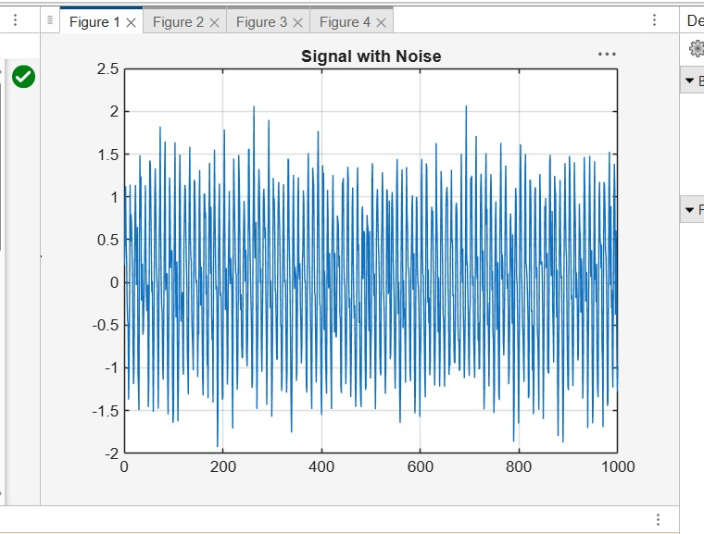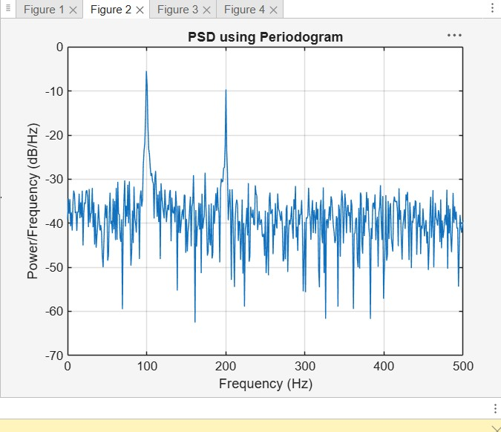

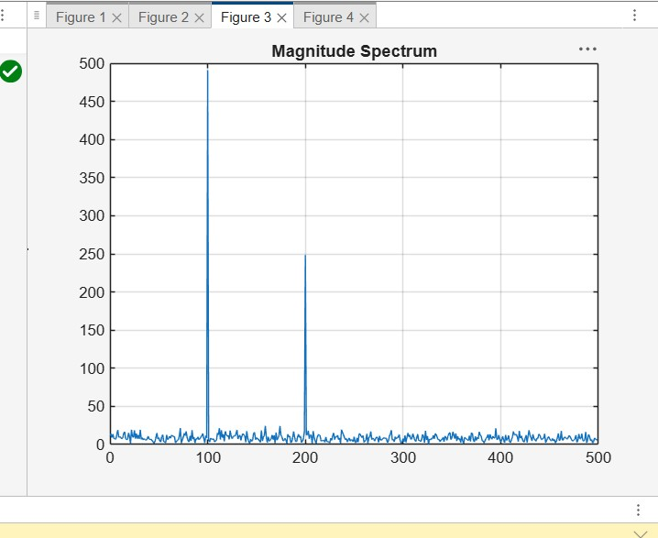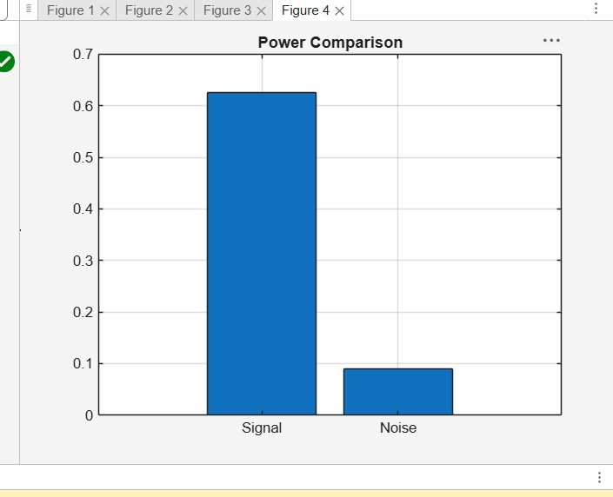
7.2

Program:
clc; clear; close all; % Signal fs = 1000; N = 256; t = (0:N-1)/fs; x = sin(2*pi*100*t) + 0.8*sin(2*pi*110*t);
NFFT = 2048; f = (0:NFFT/2-1)*(fs/NFFT);
% Windows w = {rectwin(N), hamming(N), hann(N)}; names = {'Rectangular','Hamming','Hanning'};
% Processing
for i = 1:3 xw = x(:).*w{i};
X = fft(xw,NFFT);
P{i} = abs(X(1:NFFT/2)); P{i} = P{i}/max(P{i});
end
%% Individual Spectrums
figure; for i = 1:3 subplot(3,1,i); plot(f,20*log10(P{i}),'LineWidth',1.5); title(['Spectrum using ' names{i} ' Window']); xlim([0 250]); grid on; end %% Comparison
figure; plot(f,20*log10(P{1}),'k',f,20*log10(P{2}),'r',f,20*log10(P{3}),'b','LineWidth',1.5); legend(names); title('Window Comparison'); xlim([50 170]); grid on;
%% Window Shapes
figure; for i = 1:3 subplot(3,1,i); plot(w{i},'LineWidth',1.5); title([names{i} ' Window']); grid on; end
%% Peak Detection
for i = 1:3
[pks{i},loc{i}] = findpeaks(P{i},f,'MinPeakHeight',0.3); fprintf('\n%s Window Frequencies:\n',names{i});
disp(loc{i});
end
%% Peak Marking (Hamming)
figure; plot(f,20*log10(P{2}),'LineWidth',1.5); hold on; plot(loc{2},20*log10(pks{2}),'ro','MarkerFaceColor','r'); title('Detected Frequencies (Hamming)'); xlim([50 170]); grid on;
%% Main Peaks fprintf('\nMain Spectral Peaks:\n'); for i = 1:3
[~,idx] = max(P{i}); fprintf('%s Window Peak = %.2f Hz\n',names{i},f(idx)); end
Output:
